WEEK 3: ADVANCED DATA ANALYSIS AND VISUALIZATION
Logistics Performance Analysis Using Python
Prepared by: Kanishka Sapra
Dataset: Hypothetical / Synthetic Logistics Dataset
Tools: Python, Pandas, NumPy and Matplotlib

1. Introduction
Advanced logistics analytics converts raw operational records into information that can support decisions about delivery performance, transport selection, capacity planning and cost control. This Week 3 project focuses on exploratory data analysis (EDA) and visualization of a hypothetical logistics dataset. The objective is not to claim that the results represent a real company, but to demonstrate how an analyst would structure, analyze and communicate logistics performance using Python.
The dataset contains 360 simulated shipment records covering a six-month period. Each record contains shipment date, region, transport mode, shipment volume, distance, delivery time, estimated delivery time, transport cost, handling cost, total cost and late-delivery status. The simulated values are designed to reproduce realistic operational relationships, such as longer distances tending to require more delivery time and higher shipment volumes increasing handling and total cost.

2. Dataset Structure
Variable | Type | Description | Analytical use
shipment_date | Date | Date of shipment | Trend analysis
region | Category | North/South/East/West | Regional comparison
transport_mode | Category | Road/Rail/Air | Mode performance
priority | Category | Standard/Express | Service-level analysis
shipment_volume | Numeric | Units shipped | Demand/capacity analysis
distance_km | Numeric | Shipment distance | Delivery/cost driver
delivery_days | Numeric | Actual delivery duration | Service KPI
estimated_delivery_days | Numeric | Expected duration | Late-delivery comparison
transport_cost | Numeric | Transportation cost | Cost analysis
handling_cost | Numeric | Warehouse/handling cost | Cost-driver analysis
total_cost | Numeric | Transport + handling cost | Overall cost
late_delivery | Binary | 1 = late, 0 = not late | Reliability KPI

3. Exploratory Data Analysis Methodology
The EDA follows four stages. First, the dataset structure and descriptive statistics are reviewed. Second, central tendencies such as mean and median are calculated to understand typical delivery time, shipment volume and logistics cost. Third, distributions and grouped comparisons are visualized. Finally, correlations are examined to identify variables that move together and may deserve further investigation.
The analysis uses pandas for tabular operations and aggregation, NumPy for numerical calculations, and Matplotlib for visualization. The visualizations are selected according to the question being answered rather than simply for presentation.

4. Central Tendency and KPI Results
Metric | Result | Interpretation
Mean delivery time | 3.73 days | Average delivery duration across shipments.
Median delivery time | 3.76 days | Typical midpoint; less affected by extreme values.
Mean shipment volume | 106.83 units | Average shipment size.
Mean total logistics cost | 429.86 | Average combined transport and handling cost.
Median total logistics cost | 392.74 | Typical shipment cost.
Late delivery rate | 6.94% | Share of simulated shipments exceeding estimated duration.

5. Visualization 1 — Distribution of Delivery Time
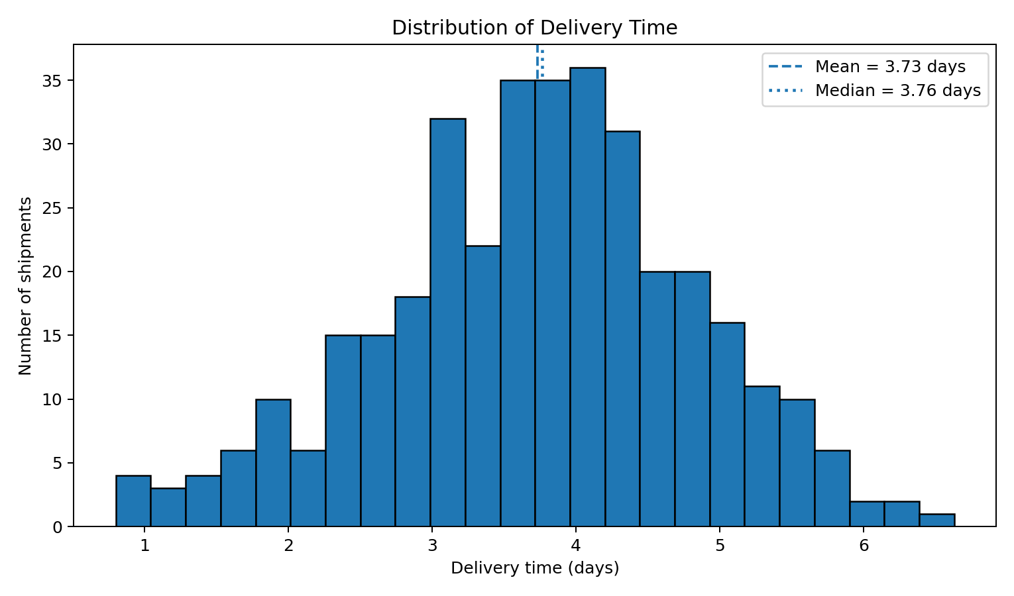
Figure 1. Distribution of simulated delivery times.
The histogram shows how delivery durations are distributed. The mean is 3.73 days and the median is 3.76 days. A histogram is appropriate because it reveals the shape, concentration and spread of a numerical variable and makes unusually long delivery times visible. Comparing mean and median also helps identify whether the distribution is pulled upward by slower shipments.

6. Visualization 2 — Delivery Time by Transport Mode
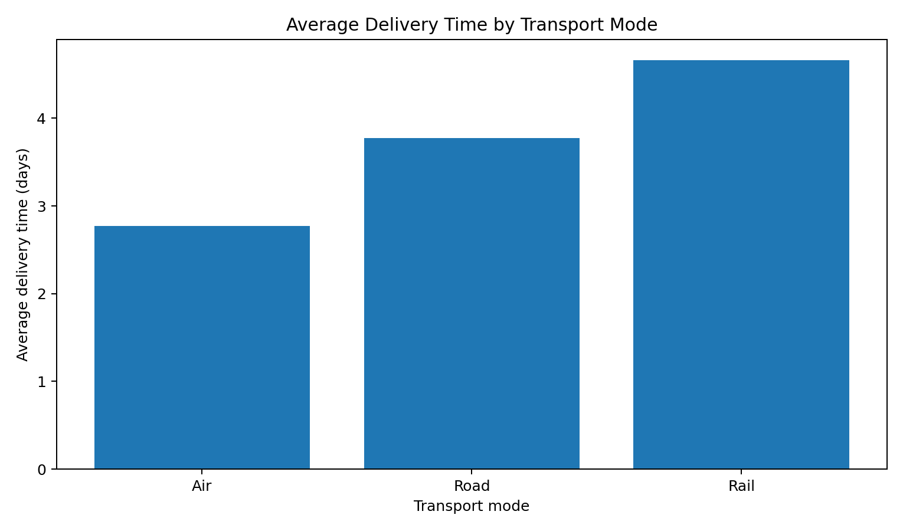
Figure 2. Average delivery time across transport modes.
The grouped comparison indicates that Air has the lowest simulated average delivery time (2.77 days), while Rail has the highest (4.66 days). A bar chart is suitable because the question compares a numeric KPI across a small number of categories. Transport mode should therefore be considered when designing service-level strategies, although cost and capacity must also be evaluated.

7. Visualization 3 — Average Logistics Cost by Region
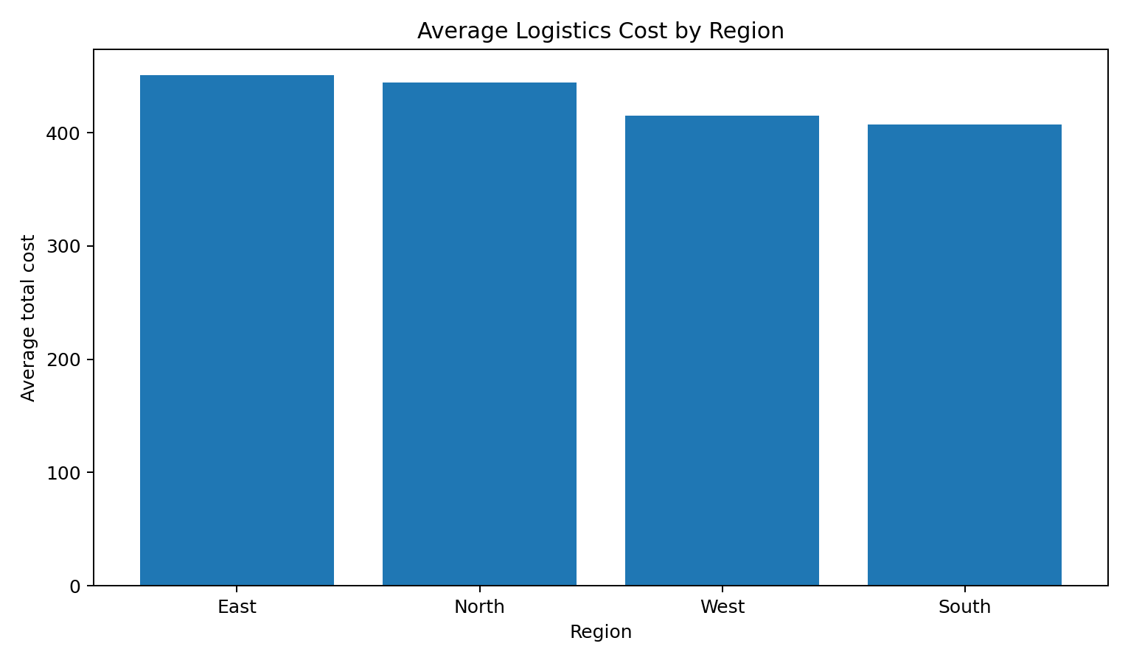
Figure 3. Average total logistics cost by region.
In the simulated data, East has the highest average logistics cost (451.02), while South has the lowest (407.38). A regional bar chart helps managers identify geographic cost differences that may warrant investigation into distance, shipment mix, carrier rates or handling requirements. The chart identifies a pattern but does not prove the underlying cause.

8. Visualization 4 — Distance and Delivery Time
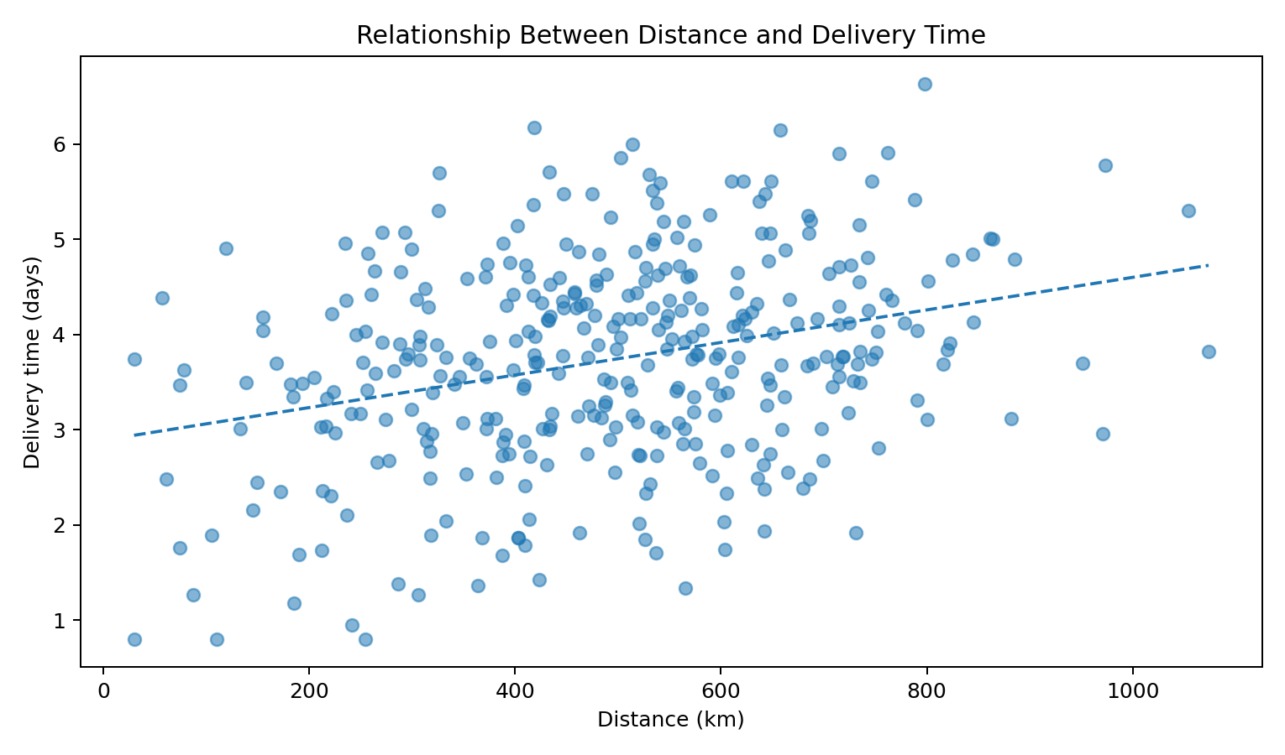
Figure 4. Relationship between shipment distance and delivery time.
The scatter plot shows the relationship between distance and delivery duration. The Pearson correlation in the simulated data is 0.30. The fitted trend line provides a simple visual summary of the direction of the relationship. A scatter plot is appropriate because both variables are continuous and individual observations need to remain visible. Distance can be considered a potential delivery-time driver, but correlation alone does not establish causation.

9. Visualization 5 — Monthly Shipment Volume
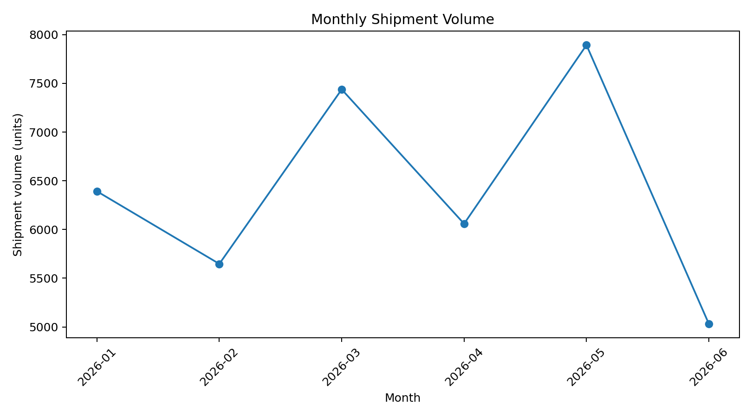
Figure 5. Monthly shipment volume trend.
A line chart is appropriate for time-series data because it emphasizes movement across ordered periods. The monthly trend can help logistics teams anticipate periods of higher workload and support staffing, warehouse capacity and carrier planning. In a real business dataset, additional years would be needed to distinguish recurring seasonality from one-off changes.

10. Visualization 6 — Correlation Matrix
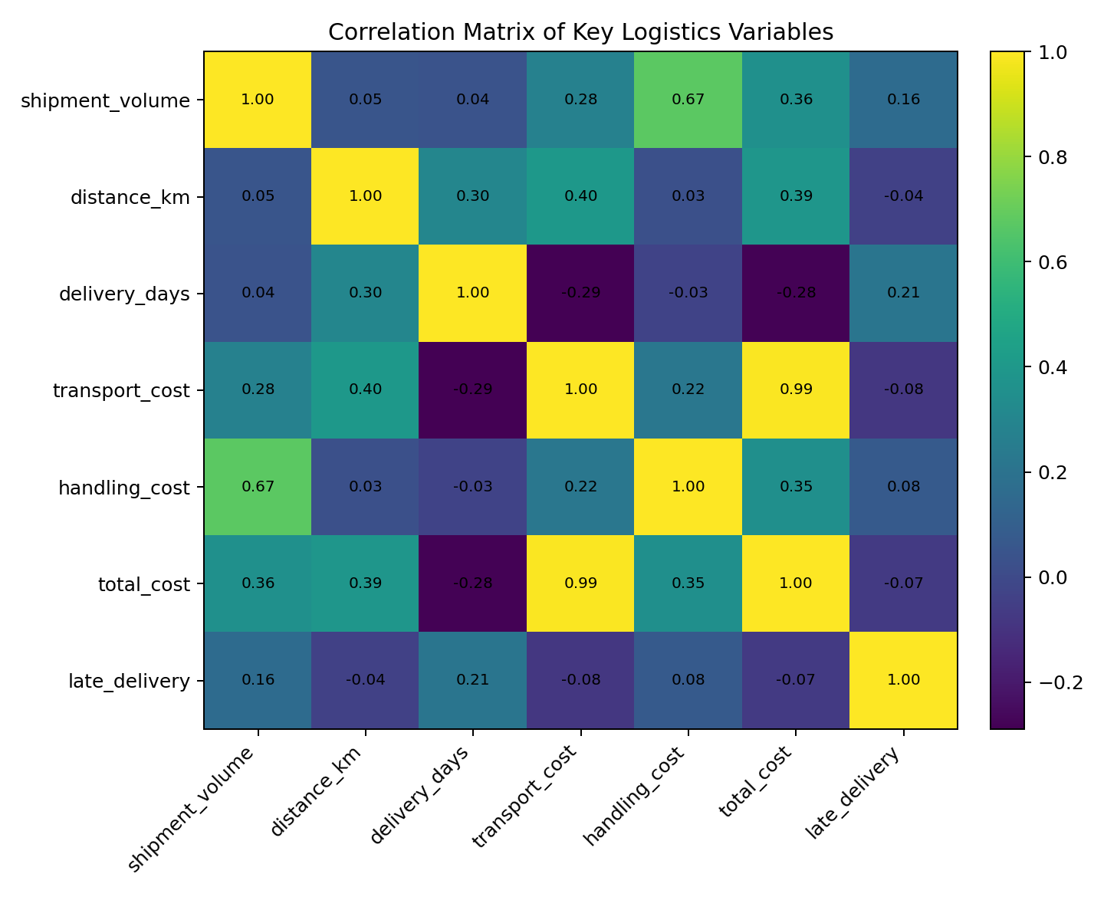
Figure 6. Correlations among key logistics variables.
The correlation matrix provides a compact view of relationships among numerical variables. For example, shipment volume and total cost have a correlation of 0.36 in the simulated data. The matrix is useful for screening variables before predictive modelling and for identifying possible multicollinearity. Correlation should be interpreted as association rather than proof that one variable causes another.

11. Transport Mode Summary
Mode | Shipments | Avg delivery (days) | Avg cost | Late rate
Air | 72 | 2.77 | 661.87 | 0.00%
Rail | 64 | 4.66 | 323.84 | 17.19%
Road | 224 | 3.77 | 385.58 | 6.25%

12. Analytical Insights
- Delivery performance: the simulated mean delivery time is 3.73 days and the late-delivery rate is 6.94%. These are baseline KPIs for monitoring service reliability.
- Transport mode: Air has the lowest average delivery duration in the simulation, while Rail has the highest. Mode selection should therefore consider both service requirements and cost.
- Distance: the distance-to-delivery correlation is 0.30, indicating a positive association in the simulated data. Longer routes may require additional planning buffers.
- Cost: shipment volume and total cost have a correlation of 0.36. Higher-volume shipments are associated with higher total logistics cost in this simulation, partly because handling and transport charges rise with volume.
- Regional bottleneck screening: East shows the highest average cost in the simulated dataset. This region should be investigated further rather than automatically labelled inefficient.
- Capacity planning: the monthly volume chart can be used to identify periods requiring additional carrier, warehouse or handling capacity.

13. Recommendations Based on the Analysis
- Monitor delivery time and late-delivery rate by transport mode and region rather than relying only on overall averages.
- Use distance and historical delivery performance to set realistic delivery-time buffers.
- Investigate high-cost regions using shipment distance, volume, carrier rates and handling requirements before changing operations.
- Use monthly shipment-volume trends to support workforce and carrier-capacity planning.
- Extend the analysis with predictive modelling to estimate late-delivery probability for individual shipments.
- Combine cost, delivery time and service-level information before making transport-mode decisions.
- Validate all simulated insights against real operational data before using them for business decisions.

14. Python Code Excerpts
# Descriptive statistics
print(df[[
"shipment_volume", "distance_km",
"delivery_days", "total_cost"
]].describe())
# Central tendency
mean_delivery = df["delivery_days"].mean()
median_delivery = df["delivery_days"].median()
print(mean_delivery)
print(median_delivery)
# Grouped logistics analysis
mode_summary = df.groupby("transport_mode").agg(
avg_delivery_days=("delivery_days", "mean"),
avg_cost=("total_cost", "mean"),
late_rate=("late_delivery", "mean")
).reset_index()
mode_summary["late_rate"] *= 100
# Correlation
corr = df[[
"shipment_volume", "distance_km",
"delivery_days", "total_cost",
"late_delivery"
]].corr()
print(corr.round(2))
# Scatter plot
plt.scatter(df["distance_km"], df["delivery_days"])
plt.xlabel("Distance (km)")
plt.ylabel("Delivery time (days)")
plt.title("Distance vs Delivery Time")
plt.show()

15. Limitations
The dataset is hypothetical and was generated for academic demonstration. The numerical values should not be interpreted as actual performance of a company, carrier or region. The analysis is also observational; correlations do not prove causation. A production logistics study would require real-time shipment scans, carrier information, route-level data, vehicle capacity, fuel prices, warehouse information and service-level agreements. Model and visualization results would also need validation on current data.

16. Conclusion
This Week 3 project demonstrates how exploratory data analysis and visualization can convert logistics records into understandable performance information. Central tendencies provide baseline KPIs, distributions reveal variability, grouped charts compare transport modes and regions, scatter plots reveal relationships between distance and delivery time, time-series charts support capacity planning, and correlation analysis helps identify variables for deeper modelling. Together, these methods provide a foundation for data-driven logistics decision-making and can be extended into predictive and prescriptive analytics.

17. References / Technical Documentation
pandas documentation — DataFrame, descriptive statistics and grouping: https://pandas.pydata.org/docs/
NumPy documentation — numerical computing: https://numpy.org/doc/
Matplotlib documentation — plotting and visualization: https://matplotlib.org/stable/

